Application for | Registration for BRKGB M-connect – Mobile Banking Facility
 | De-Registration of BRKGB M-Connect
 | Linking Bank accounts with existing BRKGB M-Connect
 | De-linking Bank Accounts with existing BRKGB M-Connect
 | Resetting of mPIN
BRANCH- | SOL ID - | REGION -

I/We request you to arrange to provide/remove above facility of Mobile Baking as per details below:
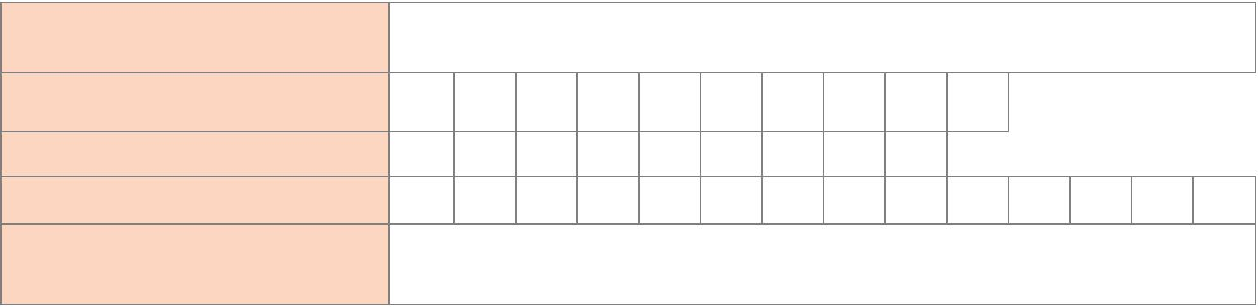
NAME OF ACCOUNT HOLDER

(In Block Letters)

MOBILE NUMBER

Where Mobile Banking will work

CUSTOMER ID

PRIMARY ACCOUNT NUMBER

Please give the choice of Account holder, in case of Joint Account with operating instructions “Either or Survivor”

COMMUNICATION ADDRESS
 | City |  | State | Pin
 | Email: |  |  | Tele. No.
 |  | Branch Name | Name of the Account Holder |  |  |  | Account Number
EXISTING ACCOUNTS | 1 |  | Self
to be linked in Mobile Banking facility. | 2 |  | Self
(Please refer the conditions overleaf)
 | 3 |  | Self
(Please ensure that all stated
accounts have the same Customer | 4
ID of the applicant) |  |  | Self
 | 5

- I / We confirm to download the Mobile Banking software as directed by the Bank through SMS or through any other mode. I / We confirm that I / we have read the ‘TERMS & CONDITIONS’ related to Mobile Banking, appearing in Bank’s website www.brkgb.com and in the reverse of this application and accept the same in full unconditionally.

- I/We undertake to state that I/We will not share my/own application password and/or mpin to any one. The complete security of above password is my/own responsibility.
- I / We understand that I/We shall be required to initiate GPRS services for availing Mobile Banking facility and hence shall be liable to pay charges to my / our respective Service Provider as per applicable tariff plan. I / We also understand that Bank would not be responsible / liable for any such charges levied by the Service Provider.

Date :

Place : Signature of first holder Signature of second holder Signature of third holder

(For Branch/Office use only)

Certified that the signature/s of the account holder/s is/are as per the records and recommended for (a) Registration

(b) De-registration, (c) Linking of accounts, (d) De-linking of accounts (e) Resetting of mPIN

Date of posting in CBS : | dd mm yyyy | Transaction ID in CBS :
 | ________________________ | ________________________
Branch : | Officer / Accountant | Name : Branch Manager
Date : | Name : | Name :
 | Sig. Number : | Sig. Number :

Terms and Conditions:

- Transactions initiated through Mobile Banking application are irrevocable; Bank shall not entertain any request for revocation of transaction or stop payment request for transactions initiated through Mobile Banking.
- Customers shall not use Mobile Banking channel for transfer of funds for illegal activities.

- Customers shall be responsible for the safe custody and security of the Mobile Banking application downloaded on their mobile phones to avoid unauthorized usage and should immediately inform Bank for disabling of Mobile Banking services in case of loss or theft of mobile phone.

- Customers should NOT share their application passwords and MPIN with anyone including Bank’s staff / associate /representative.

- Customers shall abide by the limits imposed by Bank on maximum number of transactions and maximum amount permitted through Mobile Banking. Bank reserves the right to change the number of transactions and amount at any time.
- Bank shall not be responsible for any loss to customers arising out of usage of Mobile Banking.

- Bank shall be at liberty to affect any change in Term and Conditions from time to time.

Eligibility

No | Type of Account | Constitution | Mode of operation | Eligibility
1 | SB Account | Single | Single | Account holder is eligible
2 | SB Account | Joint | E or S | As per choice of all account holders. Application to
 |  |  |  | be signed jointly
3 | SB Account | Joint | Jointly | NOT eligible
4 | SB Account | Minor | Single | Minor above the age of 15 is eligible
5 | NRE Account |  |  | NOT Eligible
6 | Current Account | In the name of | Single | The Account holder is eligible
 |  | SELF. Single
7 | Current Account | In the name of | Single | The Account holder is eligible
 |  | firm - Single
8 | Current Account | Partnership | Any one partner | The person authorized to operate. All account
 |  | Firm |  | holders will sign the application.
9 | Current Account | Partnership | Jointly operated | NOT Eligible
 |  | Firm
10 | Staff OD A/c |  |  | Eligible

Linking of accounts (Provided Customer ID of the primary account holder and “to be linked” accounts are same)
No. |  | A/cs to be linked
 | Primary Account with | SB | SB (Jt / | SB A/c | NRE A/c | C A/c | C A/c | C A/c Any
 | M-Connect | (Single) | EoS) | Jointly | Single | (Self | (Firm & | Partner /
 |  |  |  |  |  | &Single) | Single) | Jointly
1 | SB or C A/c holder | √ | √(with | x | x | √ | x | x
 |  |  | Consent

Disclaimer

It is the Customer’s responsibility to ensure that the Bank’s mobile banking application is compatible with his/her mobile phone/handset. For whatever damage or loss, if any, incurred by the Customer due to downloading of the Bank’s Mobile Banking software in his/her mobile phone, he/she shall be solely responsible. Further, the Customer shall be solely responsible/liable in keeping his/her application password and
MPIN confidential to prevent unauthorized access/use of his/her mobile banking facility by any third party. For any payment effected by the Bank to a beneficiary based on the information received by the Bank from the Customer’s mobile number registered in the Bank’s record for mobile banking facility, the Customer shall be solely responsible/liable in any manner whatsoever for any loss, claim, liability as the case may be or incidental thereto.

Declaration

I/We affirm, confirm and undertake that I/we have read and understood the Terms and Conditions for usage of the BRKGB Mobile Banking services (BRKGB M-Connect) and agree to them. I/We am/are aware that the usage of BRKGB Mobile-Banking is governed by the terms and conditions which are available on http://www.brkgb.com/ or any other site specified by Baroda Rajasthan Kshetriya Gramin Bank and I/we have reviewed the contents of the same. I/We accept and agree that I/we are aware of the contents of the terms and conditions and that all my/our rights and liabilities would be governed by the said terms and conditions by my/our act of accessing, I/we agree to adhere and comply regulation /practices set by telecom authority /regulatory/banking authority / Government of India / local / state government.etc., towards mobile operations & associated banking activities. I/we thereby agree to be subject to and comply with all the provisions of the terms and conditions which are incorporated by reference herein and deemed to be part of this application form to the same extent as if such provisions had been set forth in full herein. The Customer agrees that the Bank shall not be held liable and shall be absolved from all liabilities whatsoever, if due to any reason beyond the control of the Bank, the Bank is unable to receive or execute any of the requests from the Customer or there is loss of information during the process of transmission or processing. The Customer further agrees that he/ she shall not hold the Bank responsible/ liable for any loss whatsoever incurred to the Customer due to any failure or delay in transmission of information, if there is any error or inaccuracy of information or any other consequence arising from any cause beyond the control of the Bank which may include technology failure, mechanical breakdown, power disruption, error in transmission of information or message to any from the telecommunication equipment of the Customer and the network of any service provider and the Bank’s system or any breakdown, interruption, suspension or failure of the telecommunication equipment of the Customer or the Bank’s system”.
To be signed by Accountholders

